Muhammad Umar Farooq
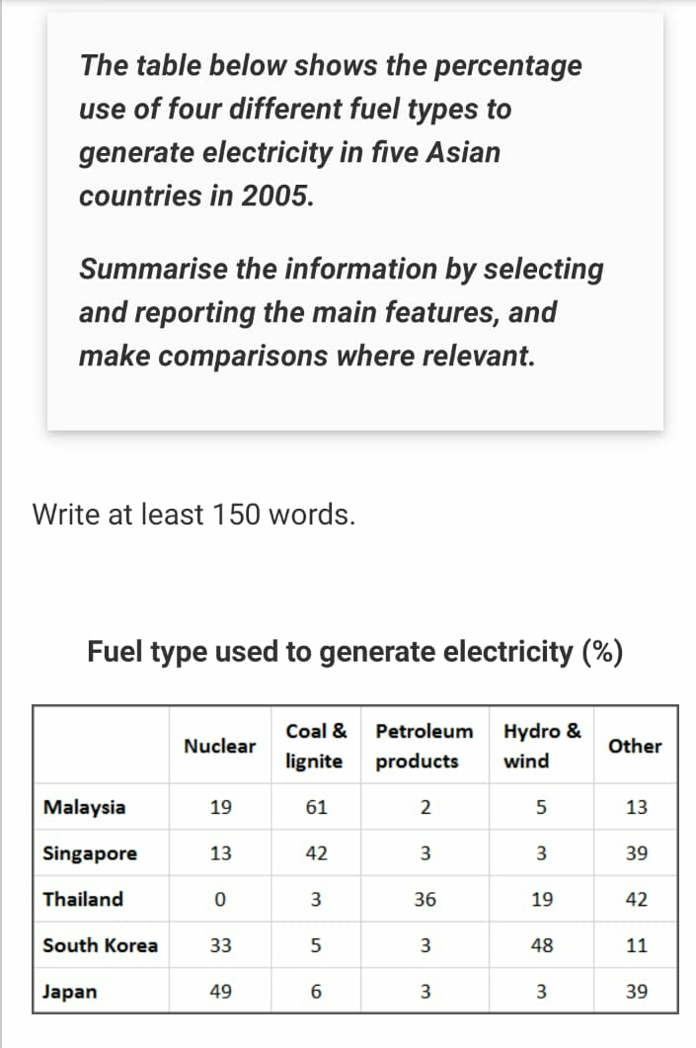
The provided table illustrates the statistical mean of consumption of distinct combustion categories to convert energy into electricity in a group of five Asian countries.
Overall, Japan and South Korea consumed nuclear as the medium of fuel to get electric power while, Malaysia and Singapore had a trend to use coal & lignite moreover, Thailand receives most of the electricity from other resources and about half of the power is generated by the petroleum products to supply electric power.
Looking at the details, Japan is at the top of the list and utilized a revolutionary approach to generate electric power, they utilized nuclear to fulfill half of the electric needs and 3% hybrid and petroleum. Meanwhile, South Korea generated 48% of its power from Hydro & wind and utilized only 3% petroleum. Furthermore, Thailand did not show any interest in nuclear it consumed petroleum products to get 36% electric energy, and 42% of the electricity gated from other mediums.
Moreover, Singapore tended to the traditional way of generating electricity and using coal & lignite to produce electricity with 42% and only 3% petroleum and hydrogen. Lastly, Malaysia was more influenced by Coal & lignite with 61% and 2% of petroleum.
ST: 10:06 -- ED: 10: 29

